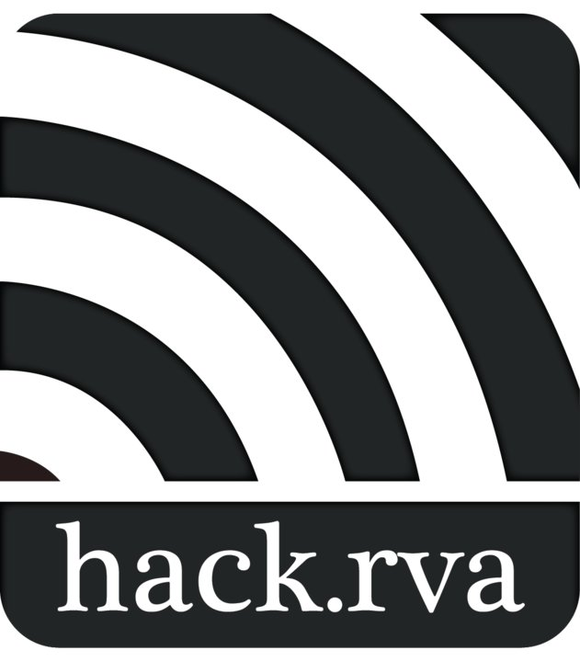 Liability Waiver vl.O

As a hakerspace and also a community of hackers and makers, HackRVA Inc. ("HackRVA"), provides its facilities, equipment, classes, and activities with the intention of creating an environment that supports collaboration, creation, and community among its participants ("Hackers" and "Makers"). To this end, HackRVA takes reasonable precautions to maintain safety of its space and equipment but cannot guarantee the safety of the participants at all times.
I acknowledge that these risks cannot be eliminated without jeopardizing the essential and/or fundamental qualities of HackRVA and its activities and events. I agree and promise to accept and assume personal responsibility for all potential risks that exist from my participation in HackRVA, including but not limited to risks that are known and unknown, anticipated and unanticipated, despite HackRVA's reasonable efforts toward safety, despite perceived negligence by HackRVA, and other faults.
My: participation is purely voluntary, and I agree that if at any time I believe or am informed conditions are unsafe, I Will immediately discontinue further participation in the activity. I also accept and agree to abide by any and all safety procedures established in HackRVA (especially as relevant to my participation) and to exercise rationality and sound judgment. I agree to utilize only the equipment and areas in HackRVA, and participate only in the activities and events, that are within the scope of my training and knowledge. Furthermore, I agree to report any accident, malfunction, or breakdown of equipment or facilities to the appropriate member of HackRVA.
I further acknowledge that inherent risks, dangers and hazards and such exist when using power tools commonly used in electronics construction, fabrication, software design and other technology-related activities. Participation in such activities and/or the use of equipment associated with technology design, fabrication or manufacture and experimentation may result in injury, illness, death or damage to personal property.
I fully assume all risks associated with participation in events and exempts and release HackRVA, its members, officers, agents and board members, from action whatsoever arising out of any damage, loss or injury to me or my property while upon the premises or using any equipment of HackRVA or while participating in any of the activities contemplated by this agreement whether such loss, damage, or injury results from the negligence of HackRVA, its members, agents, or from some other cause.
I will indemnify, save and hold harmless HackRVA, its members, officers, board members, and agents from any and all losses, claims, actions, or proceedings of every kind and character which may be presented or initiated by any other persons or organizations and which arise directly or indirectly from my actions while engaged in the activities contemplated by this agreement.
I hereby acknowledge that I have CAREFULLY read all of the provisions above, fully understand the terms and conditions expressed there, and I intend it to be a complete and unconditional release of all liability to the greatest extent allowed by law. Should any portion of this agreement be held to be invalid, its remainders shall continue to be in effect.
________________________ (Print and sign name) _______ (Date)
If signing on behalf of a minor, Minor's Name: ________________________

