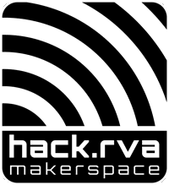 Hack.RVA Makerspace

Liability Waiver

This agreement is between
(print your first and last name)
and the HackRVA Makerspace, 1600 Roseneath Road, Suite E, Richmnd, VA 23230
 |  | By signing this agreement, I acknowledge that the HackRVA makerspace is a dangerous place and I agree to HOLD HARMLESS the HackRVA makerspace, its members, its officers, and its directors.
Initial
 |  | I also understand that I am personally responsible for my safety and actions and that I will follow all safety instructions and signage while at the HackRVA makerspace.
Initial
 |  | I WAIVE ANY AND ALL RIGHTS OF RECOVERY, CLAIM, ACTION OR CAUSE OF ACTION AGAINST HACKRVA FOR ANY INJURY OR DAMAGE THAT MAY OCCUR, REGARDLESS OF CAUSE OR ORIGIN, INCLUDING NEGLIGENCE AND GROSS NEGLIGENCE.
Initial
 |  | I affirm that I am at least 18 years of age and mentally competent to sign this liability waiver.
Initial
SIGNATURE |  |  |  |  |  | PRINTED NAME
 |  |  |  |  |  |  | INTERNAL USE ONLY
DATE |  |  |  |  |  |  | Badge:

